HORMONES

Hormones greatly influence growth, development and activity of an organism. For example, the thyroid gland in the neck produces the hormone thyroxine which ensures normal growth and development of the body. If this hormone is lacking in a tadpole, it cannot grow into an adult frog. If it is produced in excessive amounts, metamorphosis is speeded up and a very tiny frog results. Hormones have powerful effects on the body therefore their production must be balanced to prevent disastrous results.

Some hormones exercise control over other glands or muscles, while others control or coordinate body activities such as growth and development. They are the chemical messengers in animals because they assist the nervous system in coordinating the various parts of the body, ensuring that they develop and work harmoniously.

ENDOCRINE AND EXOCRINE GLANDS

Endocrine glands secrete hormones directly into the blood whereas exocrine glands produce secretions which leave the gland through a duct.

In vertebrates hormones are produced by endocrine glands. Some glands like the adrenal glands are purely endocrinal glands, producing only hormones. Glands such as the gonads and the pancreas produce both external secretions and hormones. They are therefore both endocrine and exocrine glands. The pancreas produces pancreatic juice which is carried to the duodenum via the pancreatic duct whereas, on the other hand it has a special group of cells known as the ISLETS OF LANGERHARNS ehich secrete the hormone insulin into the bloodstream.

The activities of some endocrinal glands are controlled by the nervous system e.g. the adrenal medulla whereas others are regulated by certain chemical substances. In certain cases, the chemical substances are hormones from other endocrinal glands.

The endocrine system of human beings consists of the following glands:
1. Hypothalamus And Pituitary Gland
2. The Pineal Gland
3. The Thyroid Gland
4. The Parathyroid Glands
5. The Adrenal Glands
6. Islets Of Langerhans (Pancreas)
7. Ovaries (Female)
8. Testes (Male)
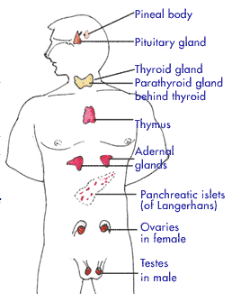

Sl. No. | Endocrine Glands | Location | Hormone | Action
1 | Pituitary (Master Gland) | Base of fore brain, pea shaped | Growth Hormone | Regulates the growth of bone and tissue.
 |  |  | Anti-diuretic hormone | Controls amount of water reabsorbed by the kidney
 |  |  | Adreno corticotrophic hormone | Defending the body against physiological stress eg. exposure to cold Follicle stimulating hormone Stimulates ovary to produce female hormone
 |  |  | Thyroid stimulating hormone | Stimulates thyroid to produce its hormone
2 | Thyroid | Neck of lower extremity of larynx, butterfly shaped | Thyroxine | Regulates rate of growth and metabolism. Too little over weight and sluggishness. Too much- thinning and over activity.
3 | Adrenal | A Pair of cap shaped organs above each kidney | Cortisone | Aids in conversion of proteins to sugar, cortex of this gland produces the hormone.
4 | Pancreas | It’s a double gland | Insulin | Regulates Sugar metabolism. Too little insulin leads to high sugar level in blood and weakness (a condition called diabetes).
5 | Ovary | Lie on the lateral walls of the pelvis | Estrogen | Development of Secondary sexual characters. Eg. Development of breasts in female.
6 | Testis | In the scrotum | Testosterone | Development of many masculine features such as growth of moustaches and beard.

IT IS IMPORTANT TO NOTE THAT:

- The pituitary gland plays an important role as a ‘controller’. It secretes a number of hormones, each of which controls the activity of a particular gland. Therefore it is also referred to as the “MASTER GLAND”.
- Some of the glands do not function until the organism reaches a certain age e.g. the gonads (reproductive organs).
- There is a difference between short term and long term hormones. The effects of hormones such as insulin are short lived whereas hormones such as thyroxine produce long term, permanent effects in the body.
- Not only the production of each hormone must be adequate but it must be balanced. Excess production of certain hormones may be harmful.
- Hormones after they have performed their function are eventually destroyed by the liver.

INSULIN

Insulin is secreted from the Islets of Langerharns present in the pancreas. The stimulus to their secretion is increase in concentration of blood glucose.

It decreases blood glucose concentration by:

- Increasing the permeability of cell membrane to glucose therefore increasing the rate of glucose uptake by cells.
- Causing the conversion of glucose to glycogen to store in the muscles and liver.
- Causing an increased oxidation of glucose during tissue respiration.

Effects of lack of secretion of insulin include the following:

- Glucose cannot be stored or utilized by tissue cells, so blood glucose concentration rises and some is subsequently lost in urine (diabetes mellitus).
- Since muscle cells have no reserve of glycogen, body weakness follows which results in continuous loss of weight.
- Body oxidizes fats instead of glucose to produce energy and this results in production of poisonous substances called ketones which are excreted in urine. Death can occur.

Effects of over secretion of insulin include the following:

- Abnormal decrease in blood sugar concentration.
- Shock results.
- Death and comma may occur.
ADRENALINE

Adrenaline is produced by the adrenal medulla which is located above the kidney. Its cause of secretion includes conditions of fear, anger, anxiety and stress. It prepares the person for fight or flight.

Following table shows a summary of effects of insulin on the different parts of the body:

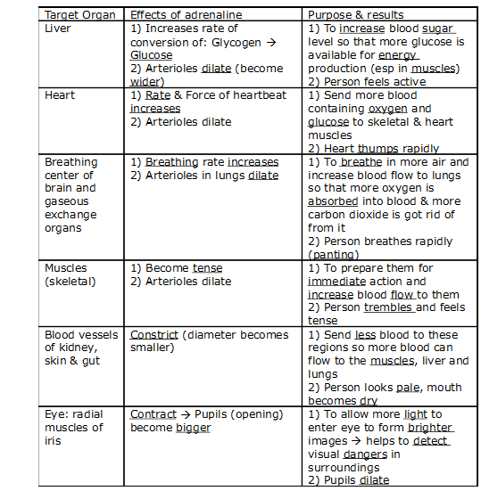

HORMONAL AND NERVOUS CONTROL

- DIFFERENCES BETWEEN HORMONAL AND NERVOUS CONTROL:

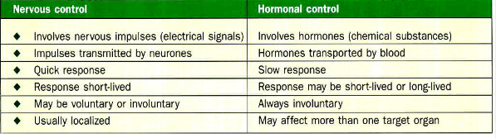

- SIMILARITY BETWEEN NERVOUS AND HORMONAL CONTROL:

Both serve as a means of coordination within the body.

